Bruno Casas Pescador B00312114 - Game Design Document

**Section V - Interface**

**Visual System**

**HUD - What Controls**

In the HUD we will find two main important features, the timer and the power bar, the timer is easy enough to understand, at the start of each level you are given a certain amount of time to complete the objective, to increase the time the player will slap people. if it goes below a threshold the music will slow down and the screen will go dimmer until it eventually goes dark, making it difficult to see how much time the player has or how much power has he obtained.

The power up bar will be located just below the timer at the top left corner, where also will be located a portrait of the main character in the attire of the level (or if the power icon or not.).

*In-game HUD.*

**Menus**

There will be a total of— menus. The first one will be the main menu where the player must click “esc” or the top right button in the in-game HUD to access. This menu will pause the game and appear in the middle of the screen as a list with the following options;

1. Options - here the player will be able to edit option such as; master volume, music volume, speech volume etc... (Discuss in group)
2. Restart level - This option is self-explanatory, if the player decides to reset the level he will just have to access here, and it should restart it.
3. Restart game - Also self-explanatory, if the player wants to restart the whole game this is where he would have to click. This button however prompts a menu asking if the player is sure about the decision he is about to take.
4. Exit to windows - This will shut down the game, as the last one, it will prompt another menu asking the player for confirmation before doing such action as it may be unintended.

*Main menu*

**Control system**

Keys in use

Up arrow - Jumping upwards

Left Arrow- Movement to the left

Down- Movement downward the on a platform or if not, ducking.

Right arrow- Movement to the right

Spacebar - slapping (movement oriented, if player i looking right he will slap right, left will slap left and ducking will make a low slap.) repeated spacebar pressing should initiate a combo if hitting an enemy.

ESC - opening main menu.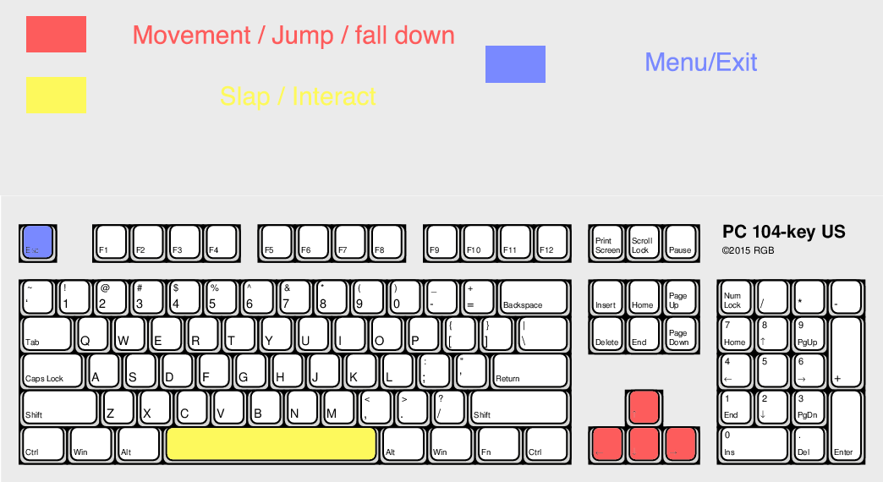

*Keyboard controls*

If using a controller (PlayStation example)

X for jumping/ unless on menu where it will count as a click.

Square for slapping

Triangle as the action button

O to activate power up/ except on menu that it will count as a back key.

Arrow keys for movement and jumping.

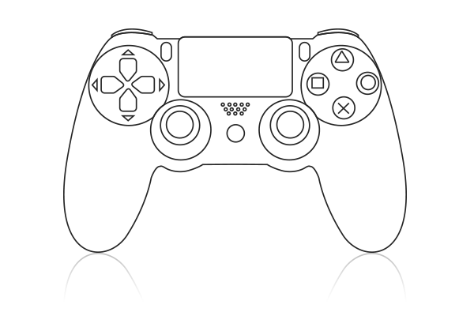Option/start for menu

Menu

Movement

Jump

Activate/ Back

Action

Slap

*PlayStation controller*

**Section VIII – Game art**

**Style Guides**

The game art style is based on 60’s and 70’s music and cinematography style including films such as “Im gonna git you sucka”, “Blacksploitation”, “Austin Powers” and also a mix of Film noir style.

These 4 distinct types of movies follow a very distinctive style of their own and make the concept of the game even more intriguing.

60’s and 70’s had a very distinguishable art style that clearly influenced the preproduction of this game.

**Characters:**

Bob Protag: Generic protagonist with very little nerve. Plain looking and a complete wimp. At least until he loses everything….

B. Wife: Wife of bob, cheated him and now dumps him. The first victim of bob’s radical change.

B. Boss: Bob’s Boss, also a boss in the game. He fires Bob and becomes his main objective.

Pedestrians: Normal people, normally scared of Bob’s actions.

Police: Main line of defense pedestrians have, they will do anything in their hand to stop Bob… Not that they will succeed in it… Will they?

University protestors: General SJW’s, try to convince Bob that he is a monster for being male. They may regret that.

Military: They appear when Bob is getting out of control. Not much to do against them unless you get them by surprise.

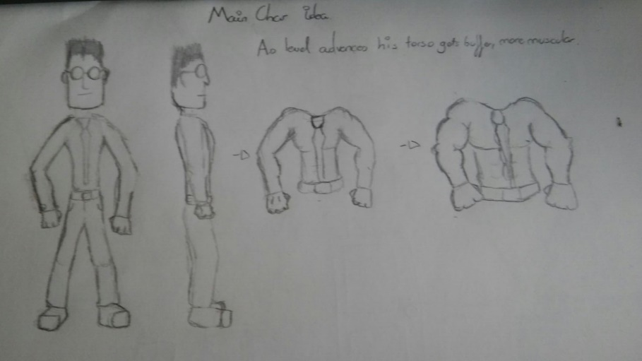

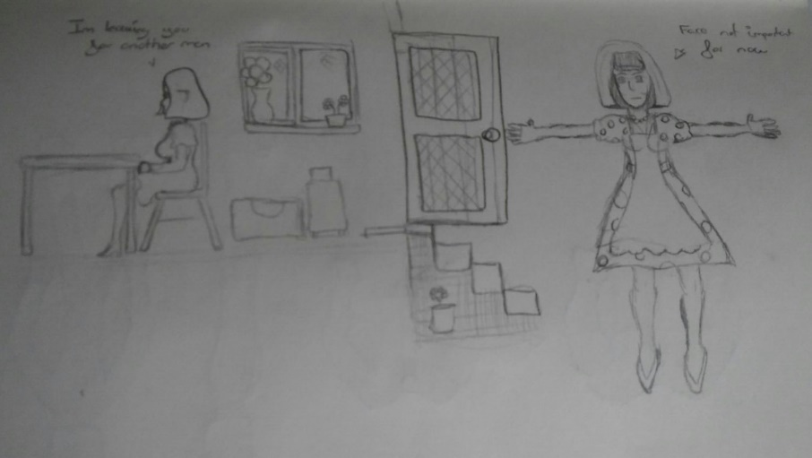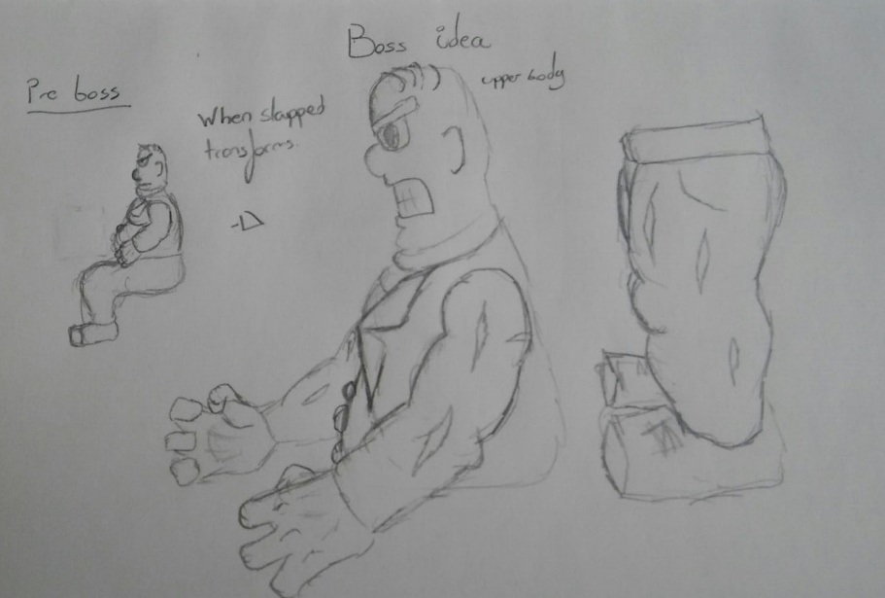

*Example of characters*

**Environments**

The environments are based on North American typical neighborhoods and a typical office and parking buildings. These would have various heights where the player may access (either roofs, windows, objects such as cars, different levels of the building when inside the office etc...)

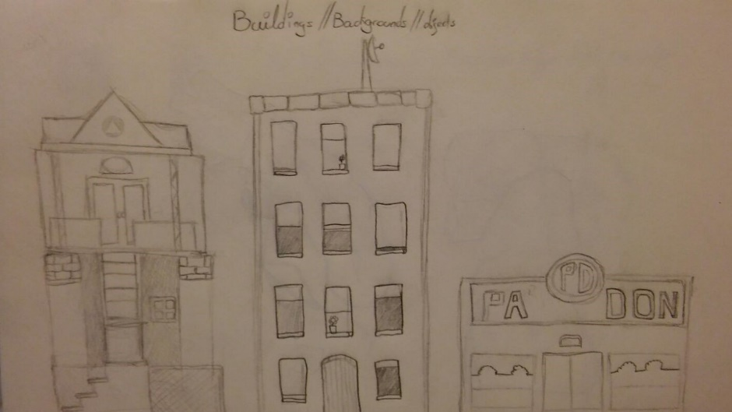

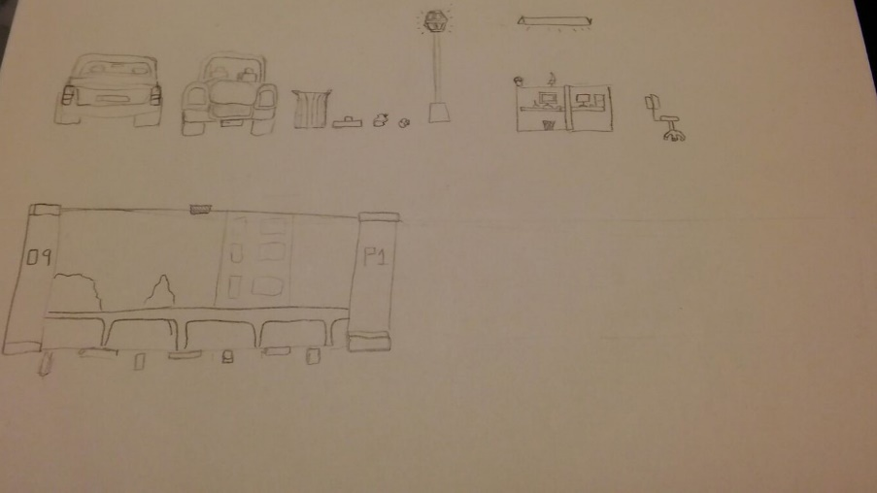

*Example of backgrounds and objects for environments*

These environments will have some interactivity with the player, cars can be jumped upon, and some roofs may be accessible with the help of some other objects such as trashcans boxes etc… Some of the npc’s will be able to make use of them too either to hide or to get to the player to attack him.

**Cut scenes**

The player will be prompt into a cut scene when he finishes each level, rewarding him and making the main character advance into the next level.  
  
These cut scenes will consist of the player in an animation of triumph for a few seconds followed by them going outside the view of the camera through the right. After this, it will fade to black and load the next level, where he will appear from the left side of the screen, at the start of the level.

In some levels however, the cutscene may be longer and include some amount of interactivity, such as keep hitting a boss or just walking away out of the level.